**Implicit Equation**

**2D Implicit Curves**

f (x, y) = 0

**3D Implicit Surfaces**

f(x, y, z) = 0

**3D Surfaces Normal**

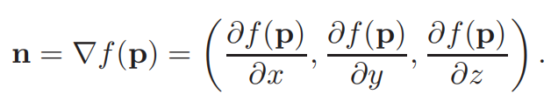

**Implicit Planes**

(p-a)·n = 0

(p-a)·((b-a)·(c-a)) = 0

**3D Implicit Curves(两个曲面相交)**

f(p) = 0

g(p) = 0